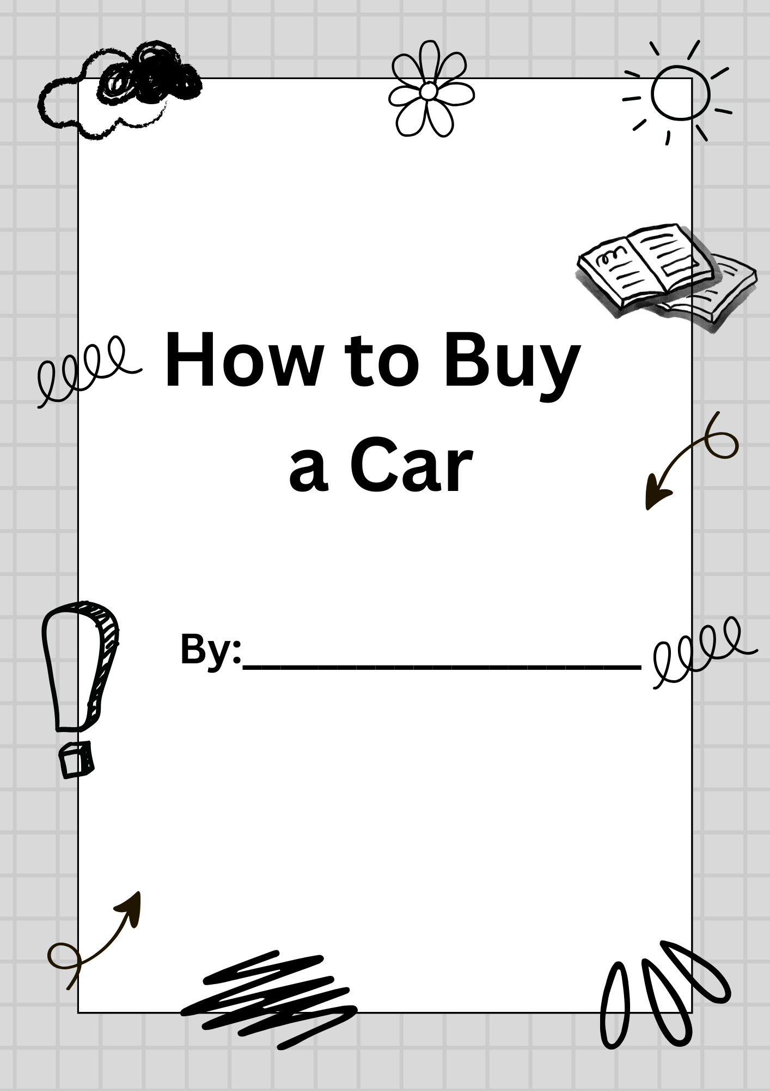

STEPS TO BUYING A USED CAR

- Research the vehicles you are interested in.
- See the vehicle in person and take it for a test drive.
  - You can also pay for a mechanic to inspect the vehicle before buying it.
  - You can also ask for a vehicle history report to make sure there are no problems with its records.
- Fill out the transfer tax form with the seller and exchange money and keys.
  - The transfer form will need to be signed by an insurance agent, so sometimes it’s good to meet at an insurance establishment to process this.
- The Insurance agent will help you register the vehicle under your name, provide a license plate, and process additional tax fees.
Note: Buying new may sound appealing, but it will put you in debt very quickly, given how fast vehicles depreciate in value. Buying used for a first vehicle is recommended, as it will help you stay within your budget, as you save for a more expensive vehicle.

Let’s start with learning a little about insurance.
ICBC Questions
Go to the website https://www.icbc.com/Pages/default.aspx and answer the following questions.
- Click on the tab “Driver licensing & ID” and then “New Drivers” and then “Graduated licensing” How many tests do you have to pass before you get a full drivers licence? How long will it take approximately?
- How can you get your Drivers Licence quicker?

- Click on the tab “Auto Insurance” and then “Products and coverage” What is basic coverage? How much Third Party Liability (TPL) coverage comes with basic coverage?

- What is Unlisted Driver Protection (UDP)? And how much can UDP be increased?

- Go back to “Auto Insurance” and then “Products and coverage” and under Optional Coverage click on “Extended Third Party” What is Extended Third party? Why might you want this?

- Now click on the link “Claims” and then “crash responsibility” How we assess responsibility in a crash?

- Who will the adjuster collect information and get statements from? Where else can an Adjuster get information from?

- Click on Crash Examples and look at some examples

Next, it is time to take your L test
- Use this link: https://www.icbc.com/driver-licensing/new-drivers/Pages/practice-knowledge-test.aspx
- Click the button that says ‘take practice test in browser’
- Finish the driver’s test
- Write down your score in the space below, and call the teacher over to see your results.
_____________________________________________________________________________
Once done, reflect on this question: Do you feel prepared for the L test, or should you study?

Driver & Vehicle Paperwork
Use these fake driver’s licenses to properly fill out the transfer tax form.
Your fake license: (pretend it has your full name, and uses the rest of the fake information)
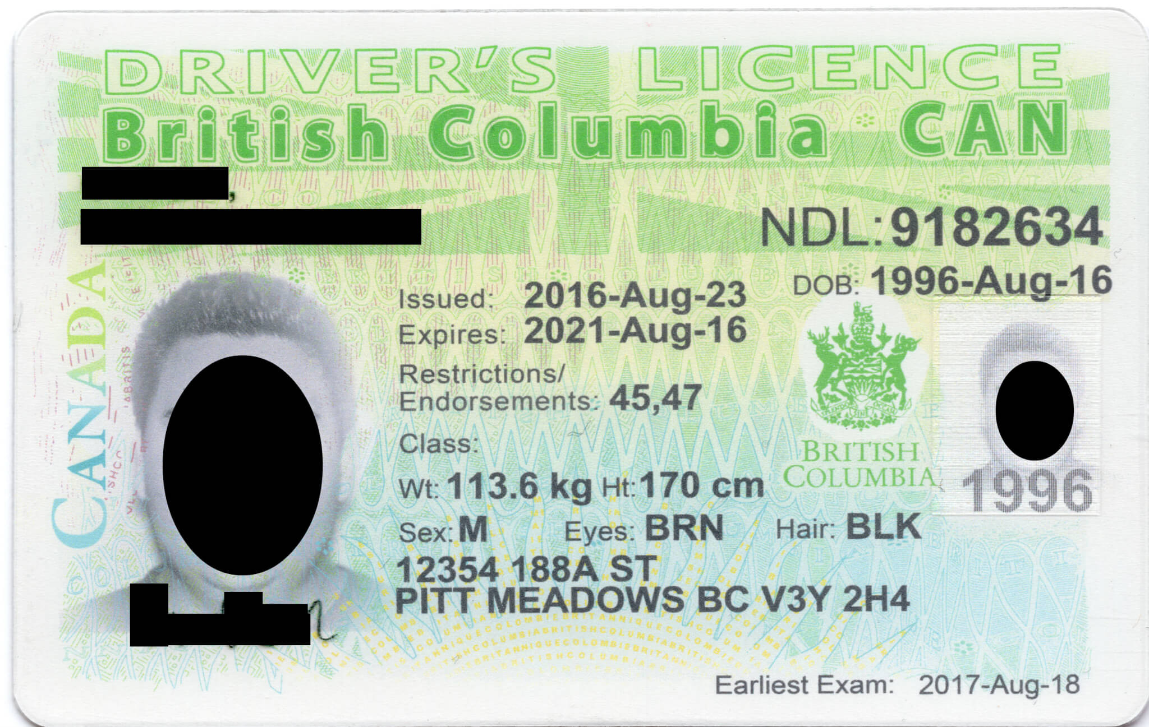YOU ARE THE BUYER!

Seller’s License:
Pretend this is all the information of the person SELLING the car to you.
They are selling it for $15,799. It has 123,985km on it.
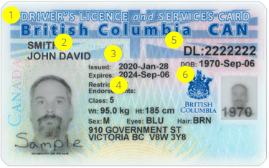

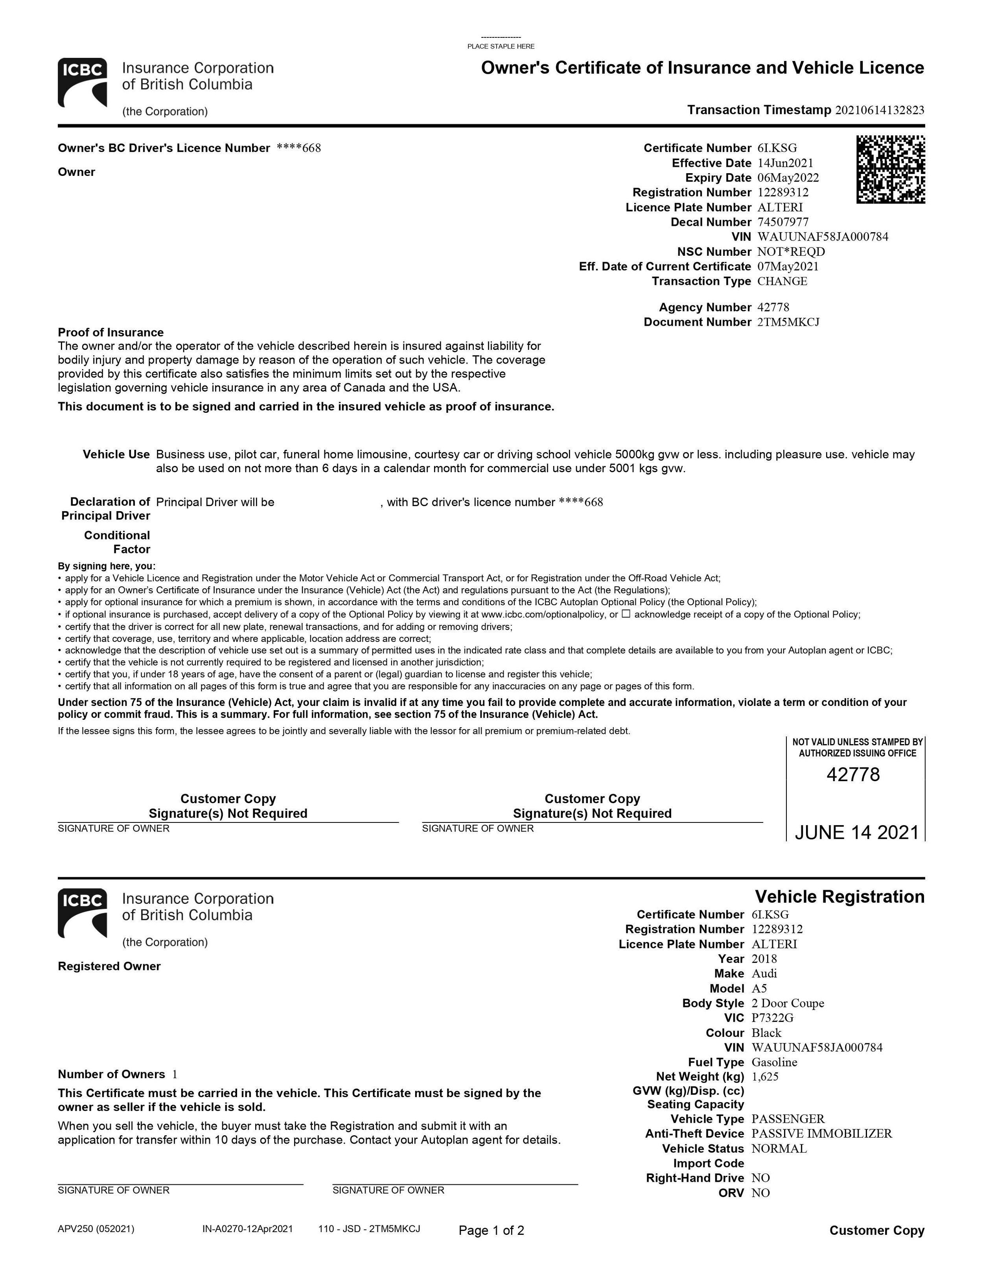USE TtrrtrttUSE
****This is a vehicle’s registration and insurance. Use this information to fill in details about the vehicle. You will need the right section of both pages.****

