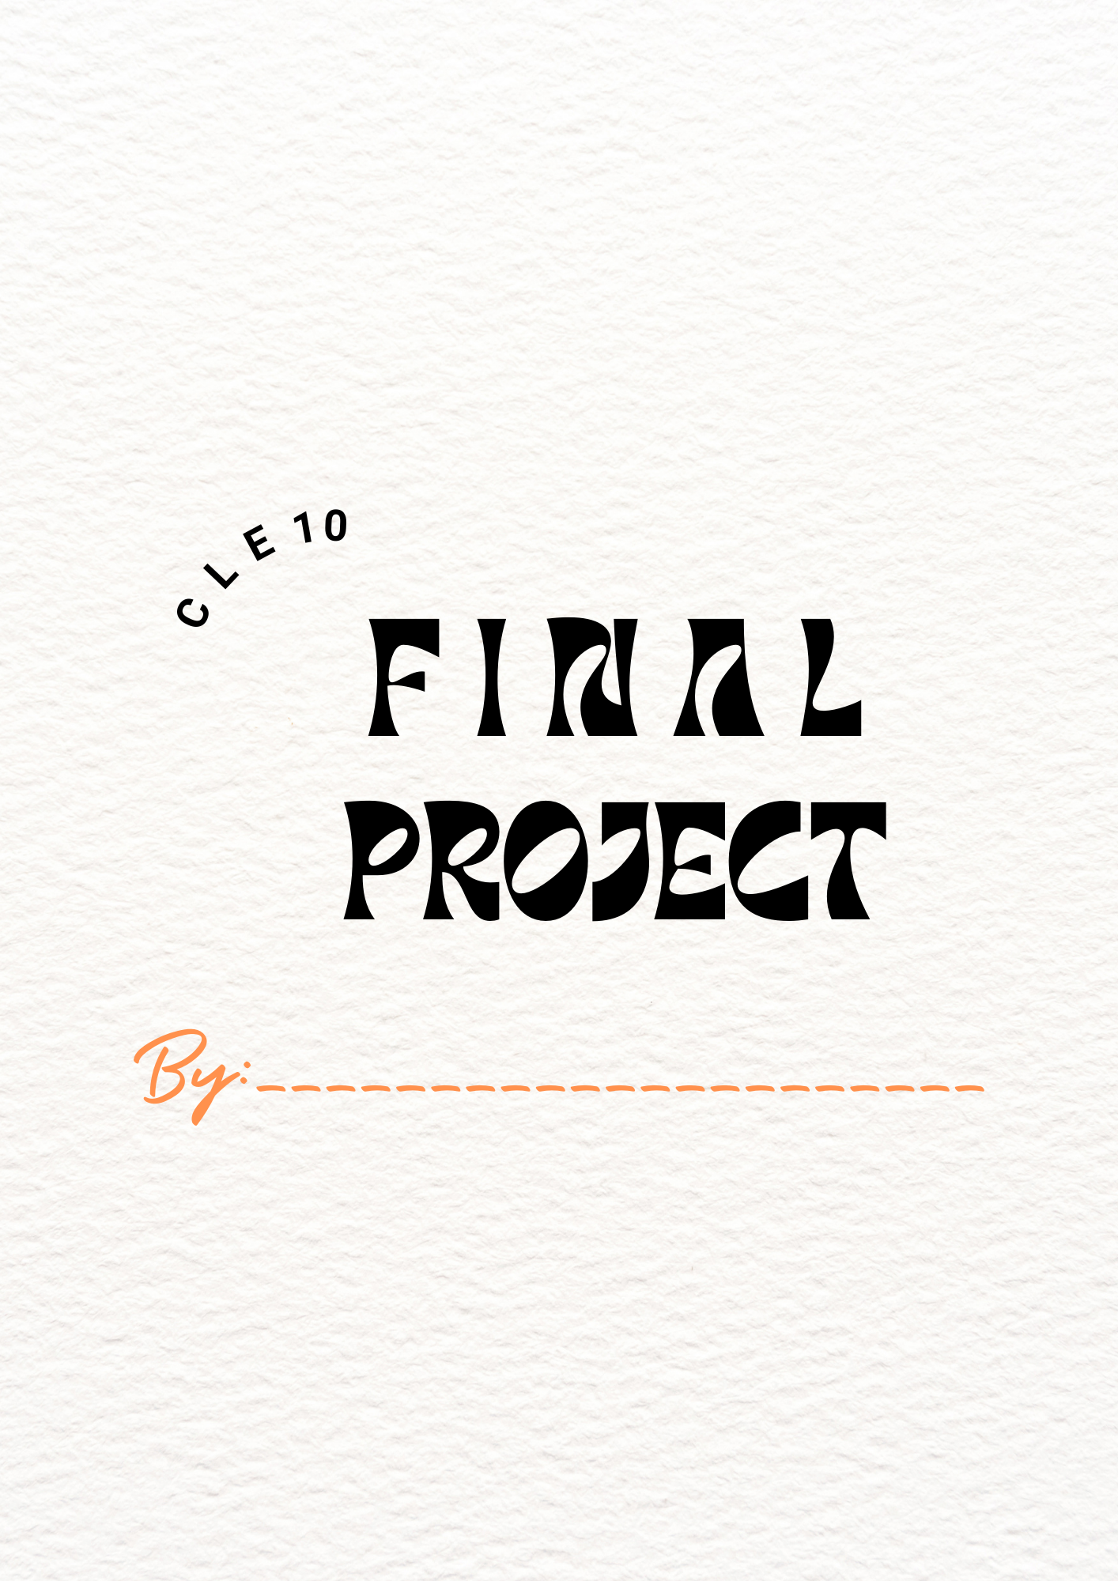
Mini Capstone Final Project
Every two weeks you will get 30 minutes of class time to help prepare you for CLC 12’s Capstone Project. Using the time given each week, you will be creating and working on a project of your own design. The rules are that the project MUST: develop a new skill, pursue a passion or interest, create change or promote change in the world. Your project must be cleared by me before starting it. You must have a clear map of what you want to accomplish, and steps you will take. This project is worth 10% of your grade, and acts as a final exam.
At the end of the semester, you will have a finished product(s) or thing to highlight and share. You will present your project individually to other adults in the building, as well as to your classmates. Think of it like a science fair—you’re not presenting to the whole class. Each week must either be spent developing or adding to your project. If you claim you are ‘done’, think of how else you could add to it. You will need to supply your own materials/equipment if your project requires that.
Brainstorming questions:
- What topic will I choose?
____________________________________________________________________________
- What are 3 goals I want to achieve with this project?

  - _______________________________________________
  - _______________________________________________
  - _______________________________________________
- What format will my end project take? (powerpoint, poster, movie)
  - __________________________________________
- Why is this format best for my project?
  - __________________________________________

- Why am I choosing this project?
______________________________________________________________________________________________________________________________________________________________________________________________________

- What will my focus/goal be for the 5 sessions we have to work on this?
  - Session 1:
______________________________________________________________________________________________________________________________________________________________________________________________________

  - Session 2:
______________________________________________________________________________________________________________________________________________________________________________________________________
  - Session 3:
______________________________________________________________________________________________________________________________________________________________________________________________________
  - Session 4:
______________________________________________________________________________________________________________________________________________________________________________________________________
  - Session 5:
______________________________________________________________________________________________________________________________________________________________________________________________________
Each week, you will add a reflection for each session to help track and show your progress throughout your project. The questions that can help you reflect are here:
    - What did you accomplish this week?
    - What barriers/obstacles are you facing?
    - What is your goal for next week?
    - How could you add to your project if you feel it is ‘done’?
    - Do you think you are moving forward with this project, or hitting a wall? Why?
- You may use the work time in class to either develop your skill (painting/knitting), or use it to write reflections/add to your final project.
    - Photo or video evidence needed if something outside of class
      - (mountain biking, rock climbing, et)
- You will discuss or showcase what you’ve done in small groups towards the end of the year.

Sample Extension options if you feel stuck
- Research a person in this career/interest field, and do a mini biography on them.
- Create a highlight reel or time lapse of your thing.
- Review a documentary or movie that is related to your topic.
- Read and review a book on your topic.
- Create a plan for a youtube channel for your topic.
- Create an advertisement for your topic/presentation.
- Develop and do a student survey on your topic for the whole school.
What should your reflections look like?
Example: Snowboarding
Session 1: I did 180’s for this week. I went to the hill and hit a jump over and over, and finally landed one. I’m going to work on 360 next.
VS
Session 1: This week I was working on landing a clean 180. A 180 involves spinning your body and board halfway around while in the air. To do this, I built a jump in my backyard and then practiced again and again in order to improve my technique. I struggled with rotating my upper body fast enough to land in a smooth way. Each time I hit the jump, it felt like my body was moving in slow motion compared to my board, so there was a delay between my board landing and my upper body catching up. I really want to be able to smoothly spin in unison with my board. I tried to adjust by doing stationary jumps and rotations, and then revisited the jump. Overall, I saw improvement, and by the end of the session I had a much cleaner landing, but it still needs work. Next session, I am going to build up to a 360 and see how I can speed up my spin.
Half of your marks come from these paragraphs, so the more detail, thought and discussion, the higher the mark.
Project Checklist
Task | Completed or Not
Planning Sheet
Session 1 Reflection Paragraph
Session 2 Reflection Paragraph
Session 3 Reflection Paragraph
Session 4 Reflection Paragraph
Session 5 Reflection Paragraph
Final Reflection of how you felt you did with your original goals
Visual Product to display in June
(powerpoint, paintings, video, poster et)
- Why you chose this
- Summary of each session
- What did you learn or what was the end result?

Project Mark Breakdown:
5 Session paragraphs | /5
Visual Product in June | /5
Total | /10

