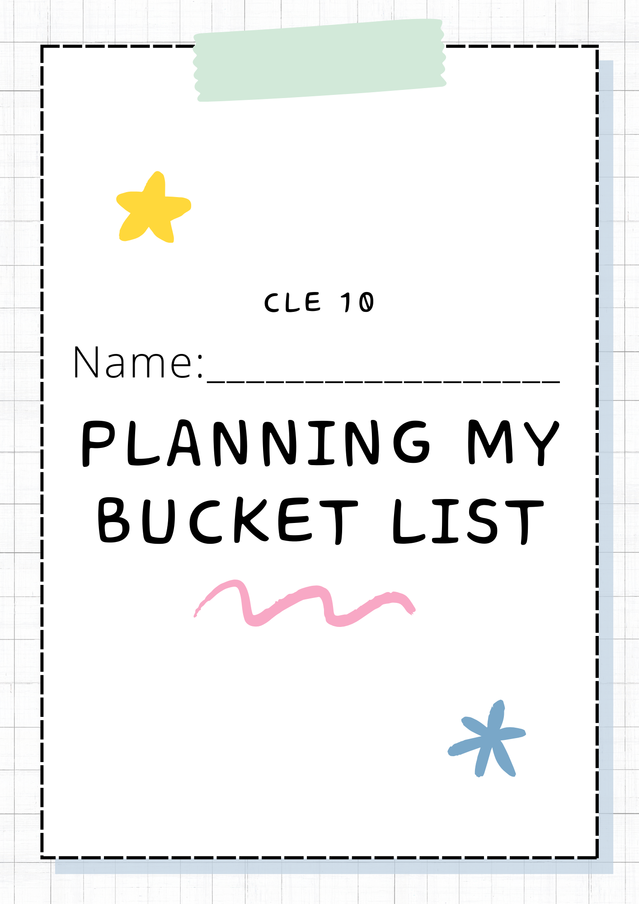
Many people end up having regrets when their time is over, so some people start what’s called a ‘Bucket List’. A Bucket List is a list of things someone wants to do before they die. You have your whole life ahead of you, but what do you want out of it? This is your chance to plan and set some life goals that you want to work toward.
Where do I start?
- Use the space below to come up with EIGHT things you want to accomplish before you die. Use the prompts below if you need a nudge in the right direction.
  - What career do you want?
  - Is there anywhere in the world you want to travel to or explore?
  - Is there a skill you want to learn? (Drive a car, design a website, et)
  - Do you want a family or partner?
  - Do you have a city you want to live in?
  - Is there something you want to try? (Bungee jumping, skydiving, et)
My Bucket list ideas:
NEXT,
In point form, write down two reason why that thing made your bucket list.
Bucket list item 1:

Bucket list item 2:

Bucket list item 3:

Bucket list item 4:

Bucket list item 5:

Bucket list item 6:

Bucket list item 7:

Bucket list item 8:
One more thing,
The last component is to have a visual representation of each thing. Use the space below to sketch an idea of what you might do for each bucket list task.
Bucket List item 1 | Bucket List item 2
Bucket List item 3 | Bucket List item 4
Bucket List item 5 | Bucket List item 6
Bucket List item 7 | Bucket List item 8

