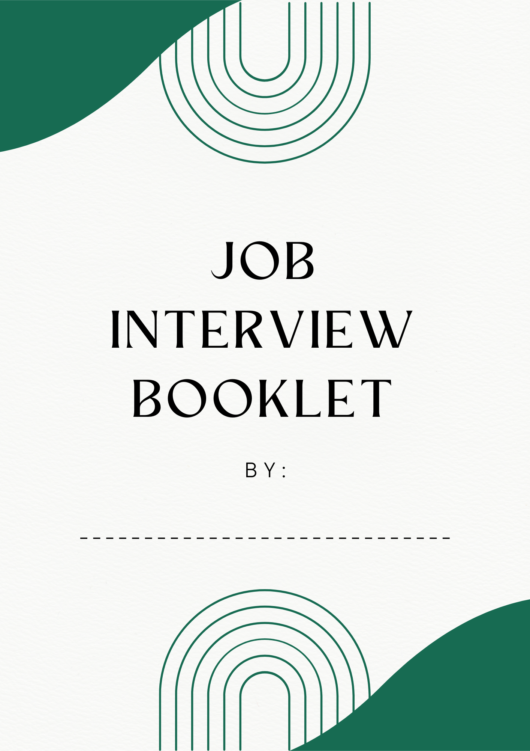

Once your cover letter and resume have your foot in the door, the employer will call you to schedule an interview. Now it is time for you to convince them to hire you. You should practice answering interview questions with as many people as possible before the real thing, to help prepare you.
Activity 1
Using full sentences, write down how you would answer these questions in a real job interview.
- Tell me about yourself.
________________________________________________________________________________________________________________________________________________________________________________________________________________________________________________________________________________________________________________________
- How would your teachers describe you?
________________________________________________________________________________________________________________________________________________________________________________________________________________________________________________________________________________________________________________________
- Why should I hire you?
________________________________________________________________________________________________________________________________________________________________________________________________________________________________________________________________________________________________________________________
- What has been your most rewarding experience so far in life?
________________________________________________________________________________________________________________________________________________________________________________________________________________________________________________________________________________________________________________________
- If you were in my shoes, what would you look for in an employee?
________________________________________________________________________________________________________________________________________________________________________________________________________________________________________________________________________________________________________________________
- Tell me about a time you dealt with a problem, conflict, or difficult situation.
________________________________________________________________________________________________________________________________________________________________________________________________________________________________________________________________________________________________________________________

- What is your biggest strength and weakness?
________________________________________________________________________________________________________________________________________________________________________________________________________________________________________________________________________________________________________________________
- Do you have any questions for me?
________________________________________________________________________________________________________________________________________________________________________________________________________________________________________________________________________________________________________________________
Activity 2
Find a partner and take turns acting as the interviewer and the applicant. For each question, try to jot down one thing your partner did very well or one thing they could improve on. Give them feedback once the interview is over, and then switch roles.
- Tell me about yourself.

- How would your teachers describe you?

- Why should I hire you?

- What has been your most rewarding experience so far in life?

- If you were in my shoes, what would you look for in an employee?

- Tell me about a time you dealt with a problem, conflict, or difficult situation.

- What is your biggest strength and weakness?

- Do you have any questions for me?

Activity 3
Find an adult in the school or at home, and have them run through a practice interview with you. Write down what feedback they gave you. Try to have at least 2 things that you need to work on.
________________________________________________________________________________________________________________________________________________________________________________________________________________________________________________________________________________________________________________________

