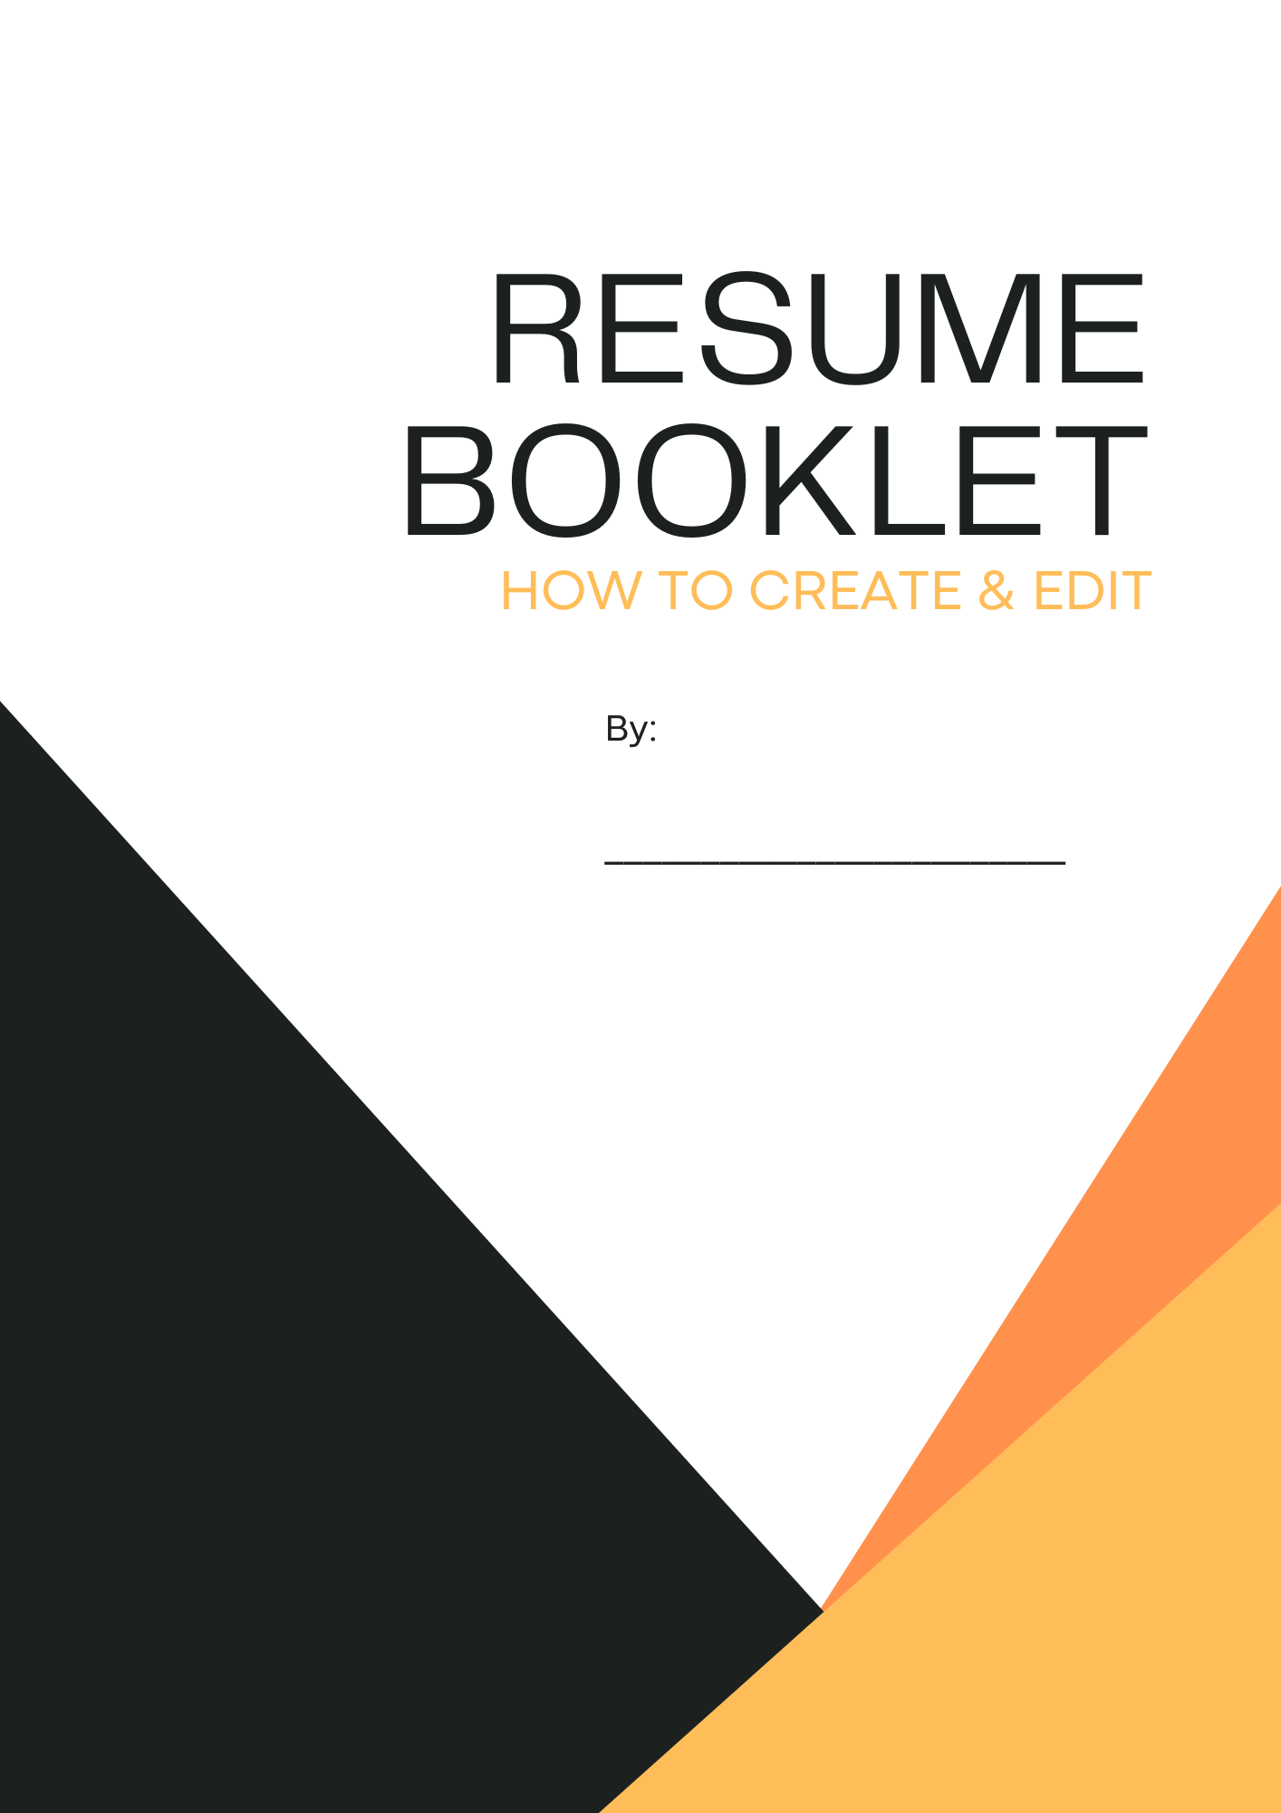

- Use the space below to write an objective for your resume. This should be 1-2 sentences either summing you and your skills up, or a specific goal you have for this business. Think about why they should pick you and not someone else, or a snapshot of who you are and what you can offer them.

- Use the space below to list 5 different skills/abilities you have, then list something that proves you have that skill. If you cannot think of 5, google ‘skills’, and choose from that list.
Skill | Evidence

- Use this space to write down three experiences you have had (volunteer, work, or training), and how that might be useful for the place you are applying to.
Experience  (Place, Role, Date) | Roles/Why this could be useful

- Use this space to think of at least 2 accomplishments you have, and why they were important for you.
Accomplishment | Importance of it

- Use this space to think of 3 adults (not related to you) who would be references. These would be people willing to say ‘You’re a good kid and will work hard’ and help you get a job. They could be teachers, coaches, role models, et.

Name | Their Role/Position | Contact info (phone/email)

YOUR NAME
___________________________________________________________________________________________________________________

Address, City, Province, Postal Code | Telephone | Email

Objective
- 1-2 sentences that explain why they should hire you. Highlight skills, relevant details, or simply state your goal is to develop your skills through work experience at_________________________.

Education

Degree 1 | Date Earned | School
- List any awards, special certificates (first aid, babysitting, et), extracurricular things.

Experience (work or volunteer)

Job Title 1(cashier) | Company(Tim Hortons) | Dates From – To(sept 2023-June 2024)
- 3-4 Roles and duties or highlights of what you did there.

job title 2 | Company | Dates From - To
- This is the place for a brief summary of your key responsibilities and most stellar accomplishments.

Skills & Abilities (if you have no experience, you need to highlight this section the most)

Name of skill (ex: Organized)
- In a bullet point or two, PROVE with EVIDENCE how you actually have this skill. Example: I balance my academic classes, achieving high grades by staying on top of all of my work

References (should have 2-3)

Name of person | Role/position they have | Phone & email

Name of person | Role/position they have | Phone & email

Name of person | Role/position they have | Phone & email

Use the next page to plan your resume and fill in the details to make it a proper resume, and completing your rough copy. Use this current page as a guide for how it could look and what information would go where.

Objective

Education

Experience

Skills & Abilities

References

