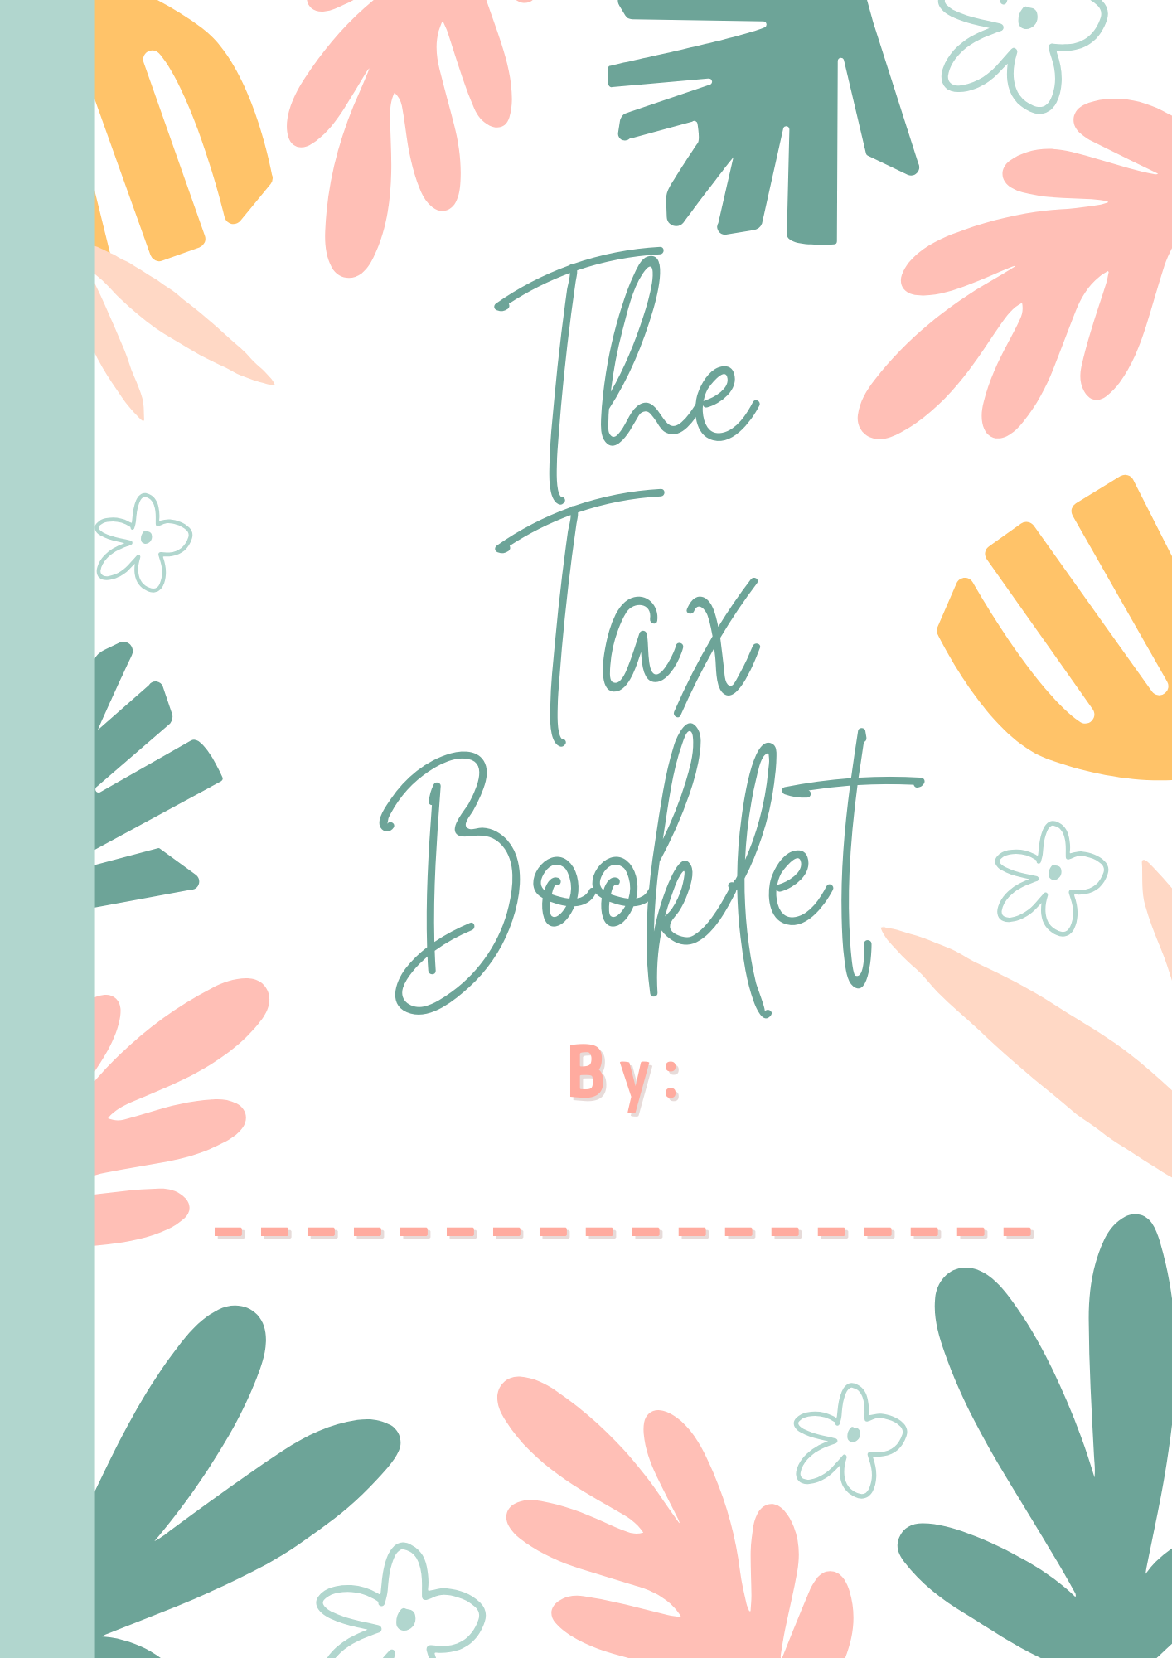
About Taxes
Taxes in Canada are mandatory payments made by individuals and businesses to the government, supporting programs like education and healthcare. Common types of taxes include income taxes, sales taxes, property taxes, customs duties, and health services taxes. Income taxes are calculated on an income tax and benefit return, while sales taxes include the goods and services tax (GST), provincial sales tax (PST), and harmonized sales tax (HST). Municipal governments calculate property taxes based on land and building value, while federal governments charge customs duties or tariffs on imported and exported products.
Canada's Public Programs and Services
• Government collects taxes for public facilities, programs, and services.
• Includes education, healthcare, roads, police, ambulance, fire services, libraries, parks, playgrounds, arenas, swimming pools, garbage and recycling collection.
• Contributes to economic development, wildlife conservation, and national defense.
Taxes contribute to social programs and benefits for low-income families, students, seniors, and disabled individuals. Employees contribute to employment insurance, Canada Pension Plans, Quebec Pension Plans, and Quebec parental insurance plans. Employers automatically deduct these contributions. Self-employed individuals pay both employer and employee contributions.
Taxes and contributions contribute to social programs and benefits in Quebec, including GST/HST credit, Canada child benefit, employment insurance, old age security pension, Canada Pension Plan (CPP), Quebec Pension Plan (QPP), and social assistance. These programs provide tax-free payments, employment insurance, parental, sickness, and caregiving leave, old age security pension, retirement pensions, and social assistance to eligible individuals and families. These programs help offset GST/HST, provide employment insurance, and offer additional benefits related to disability and health.
Why Should You Do Taxes?
Reasons to File a Tax Return in Canada
• Income tax is a common tax in Canada, used to cover various government programs and services.
• Individuals file an annual income tax and benefit return to report their income and determine if they are eligible for a refund or a balance owing.
• Benefits of filing taxes include:
- Getting a refund
- Receiving payments like GST/HST credit or Canada child benefit
- Carrying forward or transferring unused tuition credits
- Earning registered retirement savings plan (RRSP) contribution room.
When to File a Tax Return
• If you have to pay tax for the year or if the Canada Revenue Agency (CRA) requests a return.
A tax refund is owed by the CRA when you file your taxes, if you have more credits than owed, or if you are entitled to refundable tax credits. To claim and receive a refund, you must file your taxes.
The Canadian Revenue Agency (CRA) calculates various benefit payments, including GST/HST credit and the Canada Workers Benefit (CWB), using tax return information. To continue receiving benefits, individuals must do their taxes annually, regardless of income or tax-exempt status, and with their spouse or common-law partner.
Tuition tax credits can be claimed for eligible fees paid to recognized educational institutions, including post-secondary institutions and trade schools. No income is required to report eligible tuition, and they can help reduce taxes owed on income. If you didn't use all your credits, you can transfer them to your spouse, common-law partner, parent, or grandparent. You can carry forward any unused credits until they are used up, which will help you pay less tax in the future. To update your account with tuition tax credit information, you must do your taxes.
An RRSP is a retirement savings and investment plan that can be opened and contributed to to save money for the future. Deductible RRSP contributions can be used to reduce income tax. The deduction limit, or contribution room, is calculated by the CRA using various amounts, including earned income. Even if no tax is owed, you can earn more contribution room by doing your taxes annually. If you don't contribute the full amount, the CRA adds it to your contribution room for the next year. RRSP funds can also be used to buy a home or finance full-time training or education. To earn contribution room, you must do your taxes and report your income to the CRA.
What Are Your Rights & Responsibilities?
In Canada, individuals must report their income on an income tax and benefit return annually to determine if they have a balance owing or will receive a refund. This tax system is based on the self-assessment principle.

Tax deadlines are April 30 and late-filing penalties apply. To avoid penalties, complete your tax return by the due date, even if you cannot pay the balance in full. The Canada Revenue Agency (CRA) must receive accurate and complete information to process your return.

If you make a mistake or leave out income details, you can correct the situation or change your tax return. If you have a balance owing, it is due on April 30. If not paid, the CRA will start charging compound daily interest until you pay it in full.
Notifying the CRA of any personal information changes ensures you receive the necessary benefit payments and important mail.
The Canada Revenue Agency (CRA) is responsible for providing information about Canada's tax laws through various channels, such as its website and social media. It reviews tax returns to ensure accurate claims and proper supporting documents, and applies Canadian tax law consistently and neutrally. The CRA may call individuals for information, payment arrangements, tax debts, audits, or tax assistance. They also aim to reduce participation in the underground economy, which involves not properly reporting income tax or GST/HST (sales tax), which puts an unfair tax burden on law-abiding Canadians. The CRA has several compliance programs to deal with suspected tax evasion, fraud, and other tax offenses, ensuring individuals and businesses follow Canada's tax laws, including reporting income, paying taxes, and updating information that could affect benefit payments.
The Canadian Revenue Agency (CRA) believes that meeting tax obligations requires having the necessary information and services. The Taxpayer Bill of Rights outlines 16 rights, including professional, courteous, and fair treatment. It also provides guidelines for registering disputes or making complaints. If you disagree with the assessment of your taxes or the service received, you should first try to resolve the issue with the CRA. If unsatisfied, formal programs can be requested for review. It is crucial to understand your rights and apply them if needed. The Office of the Taxpayers' Ombudsperson, independent from the CRA, reviews service-related complaints and addresses issues affecting multiple individuals or populations.
History of Taxes
• Taxes existed throughout civilization, collected by rulers.
• Each society had unique laws regarding taxation, including what, when, and how much.
• Taxes were often paid with produced or gathered goods.
• Taxes funded public facilities and citizen welfare programs.
Taxes in Canada
• Canada's tax system has evolved to meet diverse, complex society needs.
• Important milestones of Canada's tax timeline are discussed in the following sections.

Before Canada's independence, the first Canadian colonies were managed by England and France's colonial governments, who collected taxes on goods brought into or out of the colonies and returned them to their control countries.
In 1867, Canada became a nation and the federal government charged taxes like customs duties and excise taxes to raise money. The Canadian government divided its responsibilities between federal and provincial governments, with the federal government responsible for infrastructure like railways and roads, and provincial governments for education, health, and welfare.
In 1914, Canada, as a British colony, joined the First World War, leading to increased customs duties and excise taxes on Canadian goods like liquor and tobacco, and higher duties on imported products.
In 1916, the federal government introduced the Business Profits War Tax Act, a temporary tax that marked the beginning of income tax. The Income War Tax Act was introduced in 1917 to finance the war, imposing a general tax on personal and corporate income. Post-war expenses continued, with a temporary sales tax introduced to cover veterans' pensions and debt interest. The sales tax was replaced by the federal sales tax in 1924.
In 1943, the government introduced the "pay as you earn" measure, allowing employers to deduct income tax directly from their employees' pay. In 1948, the federal income tax was replaced with the Income Tax Act, which was 20 pages long. In 1991, the federal sales tax was replaced with the goods and services tax (GST), and a GST credit was introduced to help families with low and modest incomes offset the tax's effects.

Questions
- Which of the following is not a type of tax collected in Canada?
A) Property tax
B) Income tax
C) Internet service tax
D) Sales tax

- What is the main purpose of collecting taxes in Canada?
A) To support public facilities and services like education and healthcare
B) To exclusively fund military operations
C) To fund private sector incentives
D) To provide financial aid to other countries

- Apart from income tax, which other tax contributions are expected from employees in Canada?
A) Import tariffs on personal belongings
B) Sales tax on personal purchases
C) Employment insurance and Canada Pension Plan contributions
D) Taxes for using public roads

- Which of the following is a benefit of filing taxes in Canada?
A) Receiving payments like GST/HST credit or Canada child benefit
B) Immediate citizenship for immigrants
C) Exemption from all future taxes
D) Avoiding military service

- By which date must individuals file their tax return to avoid late-filing penalties?
A) April 30
B) December 31
C) June 15
D) March 1

- If an individual does not have enough credits to cover the taxes owed, what happens when they file their taxes?
A) They must pay the balance owing
B) They will need to wait for a government grant to cover the difference
C) The CRA will forgive the balance as a one-time gesture
D) They will automatically be exempt from paying taxes
- How does the Canada Revenue Agency calculate the deduction limit or contribution room for RRSPs?
A) According to a fixed percentage of income
B) Based on the age of the taxpayer
C) Through a lottery system
D) Using various amounts, including earned income
- Which agency is responsible for reviewing tax returns and applying Canadian tax law?
A) Health Canada
B) Bank of Canada
C) Canada Revenue Agency
D) Canadian Border Services Agency

- What is the role of the Office of the Taxpayers' Ombudsperson in Canada?
A) To collect taxes from citizens
B) To resolve service-related complaints independently from the CRA
C) To create new tax laws
D) To enforce tax laws

- How did the federal government introduce the concept of income tax in Canada?
A) By linking it to mandatory military service
B) It was always present since the beginning of Canada's establishment
C) As a result of a public referendum in the early 20th century
D) With the Business Profits War Tax Act as a temporary tax in 1916

- What are the primary social programs supported by taxes in Canada?

- How are income taxes calculated in Canada?
- When are property taxes due, and how are they determined?
- What benefits might a Canadian receive by filing their taxes?

- Why must Canadians file their tax return annually?
- What are the consequences of filing taxes late in Canada?
- How does the Canada Revenue Agency ensure the accuracy of tax returns and the fair application of tax laws?
- What are some historical changes to the Canadian tax system since its inception?
- What rights do taxpayers have when dealing with the Canada Revenue Agency?
- How did taxes contribute to the funding of public facilities and citizen welfare programs historically and today?

How do you calculate taxes?
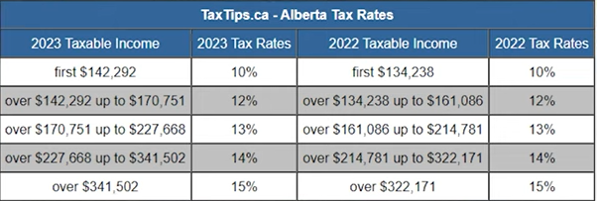There are two main types of income tax: Federal and Provincial. The Federal rates stay the same, but each province has their own numbers. These numbers can change often, so the numbers we are using are from 2023. The example we are looking at uses Alberta’s tax rates. In a later example you will have to make similar calculations using B.C.’s rates.

Practice Example:
Let’s start by pretending we live in Alberta, and make $80,000 a year. How do we calculate taxes? To begin, imagine each tax bracket as a box. Once you fill the box, you have to move on to the next one.

14%
15%
13%
12%
10%
Over $341, 502
- If we put all our $80,000 into the first box, we don’t even fill it. So, all of our salary is taxed by 10%.
$227, 668 –$341, 502
$170, 751 –$227, 668
$142, 292 –$170, 751
$0-
$142,292
  - 80,000 X .10 (this is 10%) = 8, 000
  - So, we will have to pay $8,000 of Provincial tax on our income.
- We’re not done yet, because each person is allowed a Personal Tax Credit, depending on the province they live in. In Alberta, a person is exempt for the first $21, 003 of their income.
  - How do we calculate this?
    - $21, 003 X .10 (the tax percent of the 1st box in that province) = $2, 100.3
    - So, we are exempt of paying $2,100 of our $8,000.
    - 8, 000 – 2, 100.3 = 5, 899.7
    - This means our total provincial tax that we owe is: $5, 899.7
- But wait, there’s more! We now have to do the same thing, but with Federal rates!
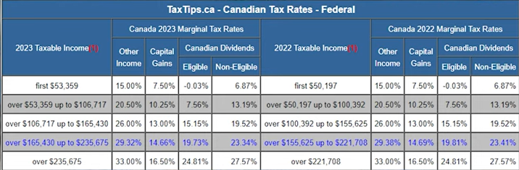Below are the Federal tax rates:
$0-
$53, 359
$53, 359 –$106, 717
15%
20.5%
26%
29.32%
33%
$106, 717 –$165, 430
$165, 430 –$235, 675
Over $235, 675

- Our income of $80,000 means we have filled box #1 fully and filled part of box #2. So how do we calculate multiple boxes?
  - Box #1:
    - 53, 359 x .15 (tax percent in box 1) = 8, 003.85
  - Box #2:
    - Start by finding out how much is in box #2
    - Take your income (80,000) and subtract box #1’s amount:
      - 80,000 – 53, 359 = 26, 641
        - This amount is how much money we have left, and how much goes into box #2.
    - 26, 641 X .205 (percent in box 2) = 5, 461.41
  - Now add the two box totals together
    - 8, 003.85 + 5, 461.41 = 13, 465.26
  - Our total Federal tax owed is: $13, 465.26
- Remember that Provincial tax credit we got? There’s also a Federal one! The exemption is on the first $15,000. Forget how to calculate this?
  - $15, 000 X .15 (tax percent in box 1) = $2, 250
  - This means, we can ignore $2, 250 of our Federal tax owed.
    - $13, 465.26 - $2, 250 = $11, 215.26
- Our last step is to add both Provincial and Federal taxes owed together
  - $5, 899.7 + $11, 215.26 = $17, 114.96
- Our total tax owed is: $17, 114.96
- Looking at our original income of $80, 000 and see what remains!
  - 80,000 – 17, 114.96 = $62, 885.04
Now it’s your turn!
Use the scenarios below, along with B.C.’s Tax Rates to calculate your income tax.
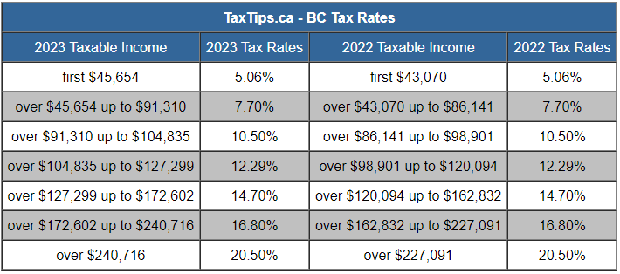
$0-
$45, 654
$45, 654 –$91, 310
5.06%
7.70%
10.5%
12.29%
14.7%
$91, 310 –$104, 835
$104, 835 –$127, 299
$127, 299 –
$172, 602

$0-
$53, 359
$53, 359 –$106, 717
15%
20.5%
26%
29.32%
33%
$106, 717 –$165, 430
$165, 430 –$235, 675
Over $235, 675

Step 1: fill each Provincial box until full, and calculate how much is taxed in each box.
Step 2: Add each box’s tax together.
Step 3: Calculate your Personal tax exemption. For B.C. The number is: $11, 981 (X by 1st box percent)
Step : Repeat process for Federal rates.
Step 5: Don’t forget to calculate the Federal Personal tax exemption: $15, 000 (X by 15%)
Step 6: Add Provincial and Federal tax together, and subtract from original income.
Scenario 1: You live in B.C. and make $80, 000.
Calculate the Provincial income tax for each box filled.
Box 1: | Box 2:
Total Provincial income tax: ___________________________
Subtract the personal tax exemption from Provincial income tax:

____________________________________
Total Provincial income tax after exemption: ___________________________________________

Calculate the Federal income tax for each box filled. Hint: You already did this in a previous example
Box 1 | Box 2
Total Federal income tax: ___________________________
Subtract the personal tax exemption from Federal income tax:
____________________________________
Total Federal income tax after exemption: ___________________________________________
Total Tax Owed (both Prov & Fed):______________________________________________________
(This should be around $15,500)
Total income after ALL taxes:______________________________________________________
Scenario 2: You live in B.C. and make $120, 000.

Calculate the Provincial income tax for each box filled.
Box 1 | Box 2
Box 3 | Box 4
Total Provincial income tax: ___________________________

Subtract the personal tax exemption from Provincial income tax:

Total Provincial income tax after exemption: ___________________________________________

Calculate the Federal income tax for each box filled.
Box 1 | Box 2
Box 3

Total Federal income tax: ___________________________
Subtract the personal tax exemption from Federal income tax:

____________________________________

Total Federal income tax after exemption: ___________________________________________

Total Tax Owed (both Prov & Fed):______________________________________________________
(This should be around $29,000)
Total income after ALL taxes:______________________________________________________

Scenario 3: You live in B.C. and make $170, 000.
Calculate the Provincial income tax for each box filled.
Box 1 | Box 2
Box 3 | Box 4
Box 5

Total Provincial income tax: ___________________________

Subtract the personal tax exemption from Provincial income tax:

Total Provincial income tax after exemption: ___________________________________________

Calculate the Federal income tax for each box filled.
Box 1 | Box 2
Box 3 | Box 4
Total Federal income tax: ___________________________

Subtract the personal tax exemption from Federal income tax:

____________________________________
Total Federal income tax after exemption: ___________________________________________

Total Tax Owed (both Prov & Fed):______________________________________________________
(This should be around $49,000)
Total income after ALL taxes:______________________________________________________

Please note: What you just did is only a FRACTION of what all of involves doing taxes. You will encounter paperwork with pages that look like this:
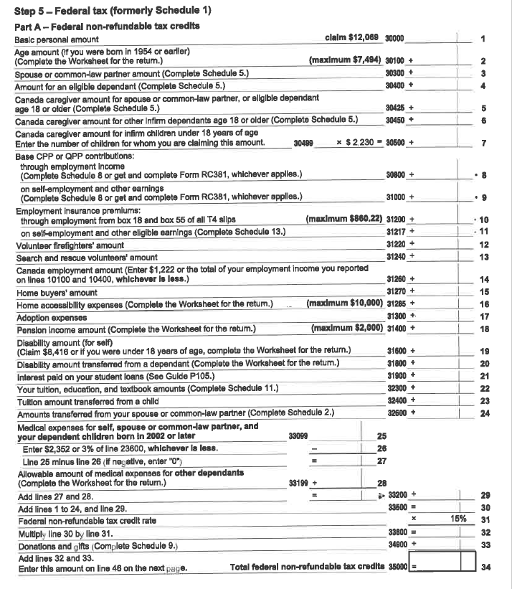

Fortunately, you don’t have to do it all on your own. There are several other options to consider:
- This is someone’s actual job; hire an accountant!
- Do the work yourself and save money.
- Use an app/program, such as TurboTax to walk you through the steps.
You should also be aware of things you can write off. This means saving your receipts to get some extra money back. This can include things like:
- Post secondary tuition
- Certain medical bills
- Certain travel expenses
- Business expenses
Taxes are a lot of work and can be very stressful. You got a small dose of this by doing this booklet. Now you can relate when people say it is ‘tax season’, and you can understand all the work that goes into doing taxes.

